Application to Open a Fund (FM003a) Help

## When to apply for a new fund

Apply for a new fund:

* When there is a new funding source
* When separate budget control and reporting is required

**Note:** For projects managed on the [Converis eResearch (eRA) system](https://eraonline.uct.ac.za/converis/portal/overview?lang=en_GB), fund opening requests must be submitted via eRA: <https://eraonline.uct.ac.za/converis/portal/overview?lang=en_GB>

## Completing the FM003a form

### Section A (completed by applicant and authorised by fund holder)

* For research funds, specify the new fund number on the form.
* If NRF or MRC research fund, obtain fund number from Central Research Finance (see guide: [NRF Fund Maintenance - Applying for new NRF funds](https://forms.uct.ac.za/NRF_fund_maintenance_Applying_for_new_NRF_funds.pdf)).
* If other research fund, obtain fund number from your Faculty Finance Office.
* **FDFP** (Foreign Donor Funded Project) refers to special foreign funding where the following criteria have been met:
* The project must be established under an Official Development Assistance Arrangement (ODAA) to supply goods or services to beneficiaries. The beneficiaries referred are the people of South Africa.
* The government of South Africa must be a party to the ODAA.
* The ODAA under which the project was established was tabled in the National Assembly as contemplated in section 231(3) of the Constitution.
* The ODAA agreement must stipulate that the funding cannot be used to pay for any taxes imposed under South African law.
* The Minister of Finance must have approved the project to be a FDFP for VAT purposes.

Therefore, just because the funding is foreign does not mean that the project is an FDFP.

* **Fund application** refers to:

|  |  |
| --- | --- |
| GOB | General Operating Budget (UCT Council approved) |
| Non-GOB | Non-General Operating Budget |
| Research | Research-related |
| Inv No 1 | Investment in portfolio 1 (Endowment) |
| Inv No 2 | Investment in portfolio 2 |
| Inv No 3 | Investment in portfolio 3 (Cash) |

* If a new cost object is required, please forward [CO103](https://forms.uct.ac.za/co103.doc) to [fnd-finance@uct.ac.za](mailto:fnd-finance@uct.ac.za).
* If relevant, attach [CO113](https://forms.uct.ac.za/co113.xls) (Fund / Cost Object Relationship) for multiple cost object links.

## Section B (completed by Faculty/PASS finance manager or nominee)

* **Fund type** refers to:

|  |  |
| --- | --- |
| Council | Income and expenditure over which Council has absolute legal control and discretion of use, except for staff and student housing which is categorised separately. |
| Council – Student/Staff Housing | Council-controlled income and expenses relating to accommodation for staff and students; including catering costs. |
| Designated | Council has no discretion/control of this income and expenditure. This restriction may result from a contract (e.g. contract research), a condition of a grant (e.g. NRF grant), a bequest (i.e. a testamentary provision in a will), or a condition stipulated in a notarial deed of donation. |
| Related Party/Non-UCT | 3rd party receipts and distribution of funds, where UCT acts as an agent. |

*Refer to* *Attachment A* *for a graphic presentation of the above and* *Attachment B* *for bursary-specific guidance.*

* **Budget Structure Template (BST)**
* This is a template that restricts postings to certain Commitment Item Groups.
* **Maintain Balance (MB)**
* This indicates if actual balance is carried forward to the next fiscal year for reporting purposes.
* **Revenue Increasing Budget (RIB)**
* This indicates if revenue will increase budget available.
* **Year End rule**
* If the budget remaining at year end closes off to a different fund, ensure that Yes is selected. (**Note:** Generally Council controlled and NRF research funds must have Year End rules).
* If the fund closes off to itself, ensure that No is selected.

### Section C. Approval by Faculty/PASS finance manager or nominee

* If the new fund is an investment fund, approval by Treasury is required before Ledgers can open the fund.

### Section D. Approval by Treasury (if an investment fund)

* If the new fund is an investment fund, Treasury must indicate approval.

## Once the FM003a form is complete

*Non-research funds and non-eRA research funds:*

* Send the completed FM003a to [fnd-ledgers@uct.ac.za](mailto:fnd-ledgers@uct.ac.za) if not an investment fund, or [fnd-treasuryreq@uct.ac.za](mailto:fnd-treasuryreq@uct.ac.za) if an investment fund.
* Ledgers will inform you when your fund has been opened and will provide you with the fund number.

*eRA research funds:*

* [FM003a](http://forms.uct.ac.za/fm003a.docx) for research funds must be submitted via the [Converis eResearch (eRA) system](https://eraonline.uct.ac.za/converis/portal/overview?lang=en_GB).

# Attachment A:

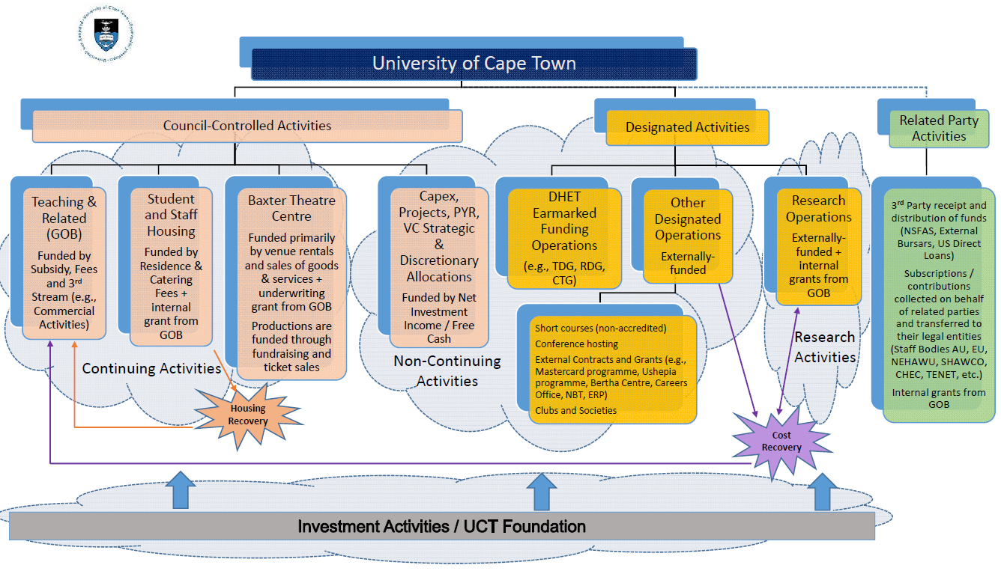

# Attachment B:

Below are examples of what fund type is appropriate when opening bursary funds:

|  |  |
| --- | --- |
| **Fund type** | **Bursary scenario** |
| Council-controlled | * Money received with no terms and conditions and UCT decides to use the money for bursaries. * GOB allocation for bursaries. |
| Designated | * Money received with a stipulation that the money be used for bursaries, but UCT can decide on the students that will receive the bursaries.  Example: Funder stipulates: "R10 000 donation to be used for bursaries for students in their 3rd year engineering degree". * Bursaries where UCT provides the funder with a list of students and the funder chooses which students they want to give bursaries to. |
| Related party/non-UCT | * Money received where the funder specifies which students must receive the money (without any UCT involvement).   Therefore, UCT is just acting as an agent to allocate the money on to the student's fee account).  Example: Funder says: "R10 000 each for students x, y and z". * All NSFAS funding |